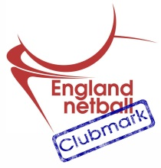
HATFIELD NETBALL CLUB
AFFILIATED TO THE ALL ENGLAND NETBALL ASSOCIATION
Clubmark – Silver Award

HNC Data Protection Policy
- HNC must have legitimate grounds for collecting and using the personal data;
- HNC will not use the data in ways that have unjustified adverse effects on the individuals concerned;
- HNC will handle people’s personal data only in ways they would reasonably expect; and
- HNC will not do anything unlawful with the data.
- HNC will be clear from the outset about why data is collected and what the intended use is
- HNC ensure that if the club wish to use or disclose the personal data for any purpose that is additional to or different from the originally specified purpose, the new use or disclosure is fair.
- HNC will only hold personal data about an individual that is sufficient for communication within the club regarding netball matters; and
- HNC will not hold more information than is needed for that purpose.
- HNC take reasonable steps to ensure the accuracy of any personal data that is obtained;
- HNC ensure that the source of any personal data is clear;
- HNC carefully consider any challenges to the accuracy of information; and
- HNC consider whether it is necessary to update the information.
- HNC will only retain personal data for the current and previous season;
- HNC will securely delete information that is no longer needed for the purposes of club business
- Any HNC member has a right of access to a copy of their personal data held by the club;
- Any HNC club member has a right to object to processing that is likely to cause or is causing damage or distress;

